SQL
Session-5
1.Create two tables in SQL: influencers (with influencer_id as PRIMARY KEY and name) and posts (with post_id as PRIMARY KEY, influencer_id as FOREIGN KEY, and caption). Insert at least 3 influencers and 2 posts for each influencer.
CREATE TABLE Influencers(influencers_id INT PRIMARY KEY AUTO_INCREMENT,name varchar(50));

INSERT INTO influencers (influencers_id, name)
VALUES
(1, 'Rishi Prajapati'),
(2, 'Rahul Sharma'),
(3, 'Sanjana Patel');
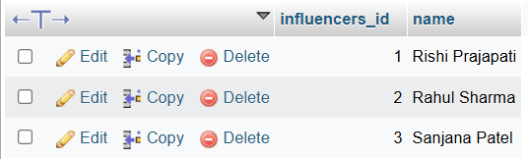

CREATE TABLE Posts(post_id INT PRIMARY KEY AUTO_INCREMENT,influencers_id INT,caption varchar(200),FOREIGN KEY (influencers_id) REFERENCES influencers(influencers_id));

INSERT INTO posts (post_id, influencers_id, caption)
VALUES
(101, 1, 'Exploring new places!'),
(102, 1, 'Coding and learning every day!'),

(103, 2, 'Fitness motivation!'),
(104, 2, 'Morning workout routine!'),

(105, 3, 'Weekend vibes!'),
(106, 3, 'Travel memories!');
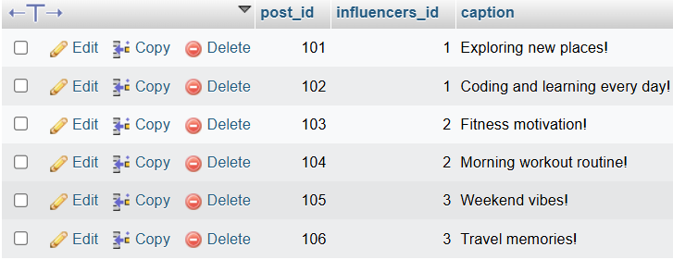
2.Write an SQL query using INNER JOIN to display each post's caption along with the name of the influencer who posted it, based on the tables you created.
SELECT posts.caption AND influencers.name FROM posts INNER JOIN influencers on posts.influencers_id =influencers.influencers_id;
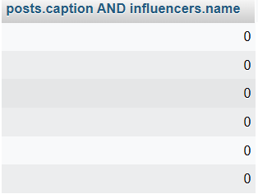

3.Write an SQL query using LEFT JOIN to show all influencers and their posts, including influencers who haven't posted anything yet. If an influencer has no posts, display 'No Posts' in the caption column.<br><br><em><strong>Hint:</strong> Use IFNULL or COALESCE to handle NULL values in the result.</em>
SELECT name, COALESCE(posts.caption, 'No Post') AS caption
FROM influencers
LEFT JOIN posts
ON influencers.influencers_id = posts.influencers_id;
Output:
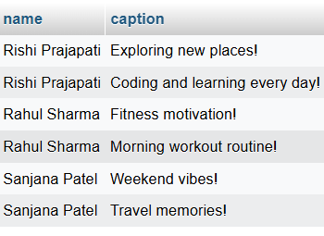
4.Write an SQL query using RIGHT JOIN to list all posts and the corresponding influencer's name, ensuring that even posts without a matching influencer_id (if any) are shown.
SELECT posts.caption , influencers.name
FROM influencers
RIGHT JOIN posts
ON influencers.influencers_id = posts.influencers_id;
Output:
